

## Topic: Using Recently Viewed Documents

Want to quickly find a document you reviewed recently? theSource can help with that. Just click on the Recently Viewed Documents icon on theSource Home page.



Recently Viewed Documents are categorized by **Today**, **Yesterday,** and **Older**. Select the dropdown arrow for the category you wish to view.

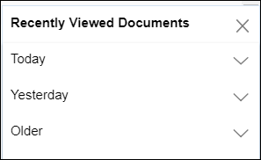

**Result:** A list of up to 20 previously viewed documents will display (order can vary).

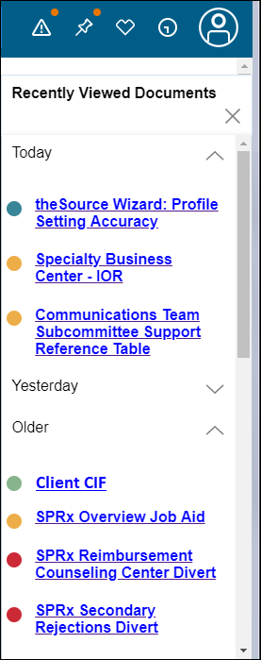

 Your next challenge on the quest to becoming a Certified theSource Wizard is to access the Recently Viewed Documents icon on theSource Home page the next time you need to revisit a document you have looked at in the last few days.

Additional resources:

* Become a Certified theSource Wizard: Index

Not to Be Reproduced or Disclosed to Others without Prior Written Approval

**ELECTRONIC DATA = OFFICIAL VERSION / PAPER COPY = INFORMATIONAL ONLY**